EARL SOHAM NEIGHBOURHOOD PLAN BACKGROUND

What is a Neighbourhood Plan?

A Neighbourhood Plan is a statutory planning document whose policies must be used by East Suffolk District Council when considering new applications for development in the Parish.
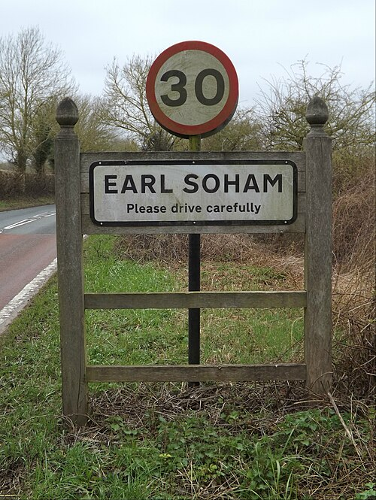

Why does Earl Soham need a Neighbourhood Plan?

All local authorities are under pressure to build new homes and landowners and developers respond to this by putting forward sites for development. A Neighbourhood Plan allows the community to make statutory planning policies that are specific to the Parish to protect us from over-development. If we have a Neighbourhood Plan, we set the policies that control new development.

What is the requirement for new houses in Earl Soham?
The East Suffolk District Council has set us a requirement of 25 new homes by 2036.

What are the benefits of having a Neighbourhood Plan?
Allows the Community to decide where new developments should take place (providing greater local control)

Earl Soham Parish Council will receive 25% of the Community Infrastructure Levy (CIL) paid by the developers on all new developments in the parish

Can help us to protect the local environment

Stops excessive development in the village/parish

Stops developers crating big new estates around the village/parish

Who pays for the Neighbourhood Plan?


Most of the funding needed to produce our Neighbourhood Plan comes from the Ministry of Housing, Communities & Local Government. The balance is made up by a small grant from the Parish Council.

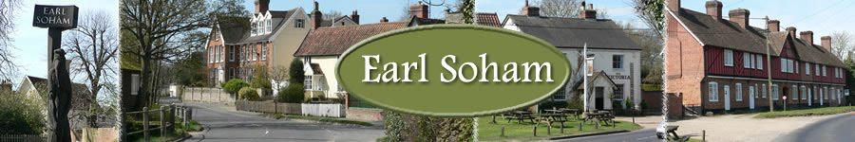

Contextual Information

For more broader information on local (Suffolk) and national Planning please see:

East Suffolk Local Plan 2020
https://www.eastsuffolk.gov.uk/planning/planning-policy-and-local-plans/

Suffolk County Council https://www.suffolk.gov.uk/planning-waste-and-environment/planning-and-development-advice/neighbourhood-planning-guidance

National
https://www.gov.uk/government/publications/national-planning-policy-framework--2

Earl Soham Neighbourhood Plan Project Group

The Earl Soham Neighbourhood Plan Project Group launched in 2017, progressed various activities including local survey, analysis of local demographics, call for potential land etc.

This work stalled during the COVID lockdown period and lost momentum afterwards.

Having received appropriate updates, the Parish Council considered it necessary to ‘relaunch’ this project in June 2025 with a narrower focus on ‘housing’.

Much of the initial work remains relevant and can be used in moving forward.
EARL SOHAM NEIGHBOURHOOD PLAN PROCESS & KEY STAGES

ACTION | DETAIL | TIMEFRAME
Re-form Project Team | Previous work reviewed, plan of action formed | Completed July 2025
Community Engagement Event | Update local community on action & invite views, comments, ideas etc. | Planned for 8th & 9th November 2025
Survey of Local Community | Invite views from local community on housing needs and development ideas | Questionnaire to be circulated by 30th November 2025. To be returned by 31st December 2025.
Analysis of Local Community Survey |  | January 2026
Call for expressions of interest from local landowners | Expressions invited for potential sites for development against identified criteria | Following completion of analysis of Survey
Analysis of ‘potential sites for development’ submitted | Assessed by external specialists | Following the above
Completion of draft Neighbourhood Plan | Based on above identified action & analysis | Autumn 2026
Referendum on draft Neighbourhood Plan | Containing options for proposed housing development | Winter 2026
Plan Presented to East Suffolk Council for ratification |  | Spring 2027

